09: sequence diagram
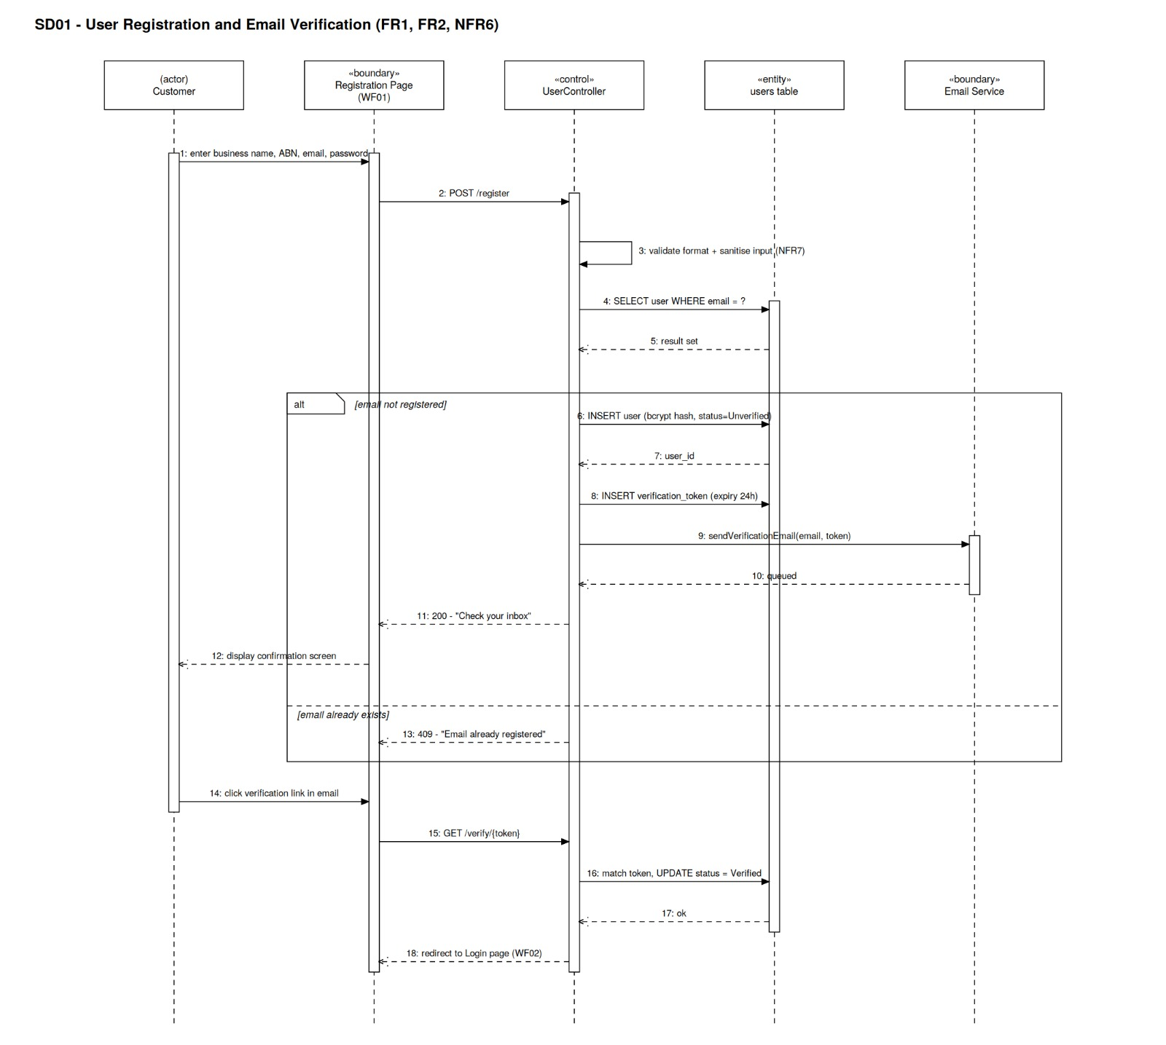

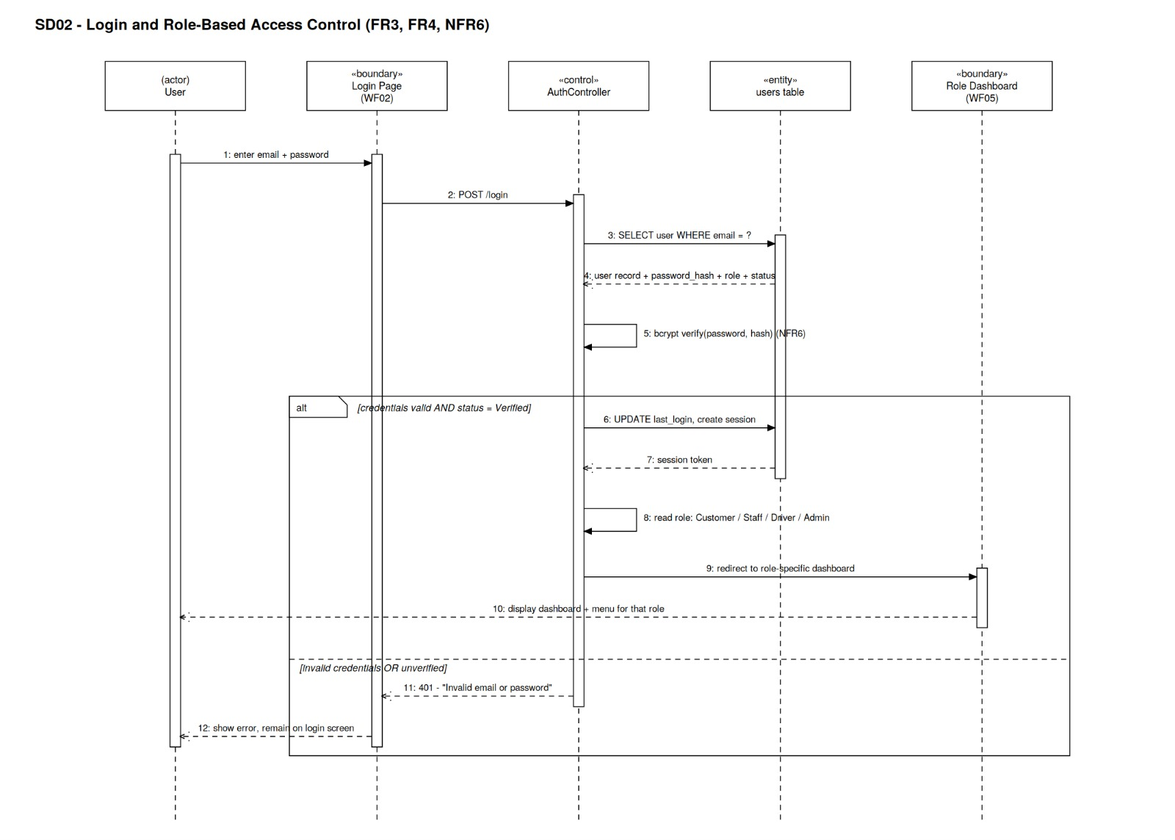
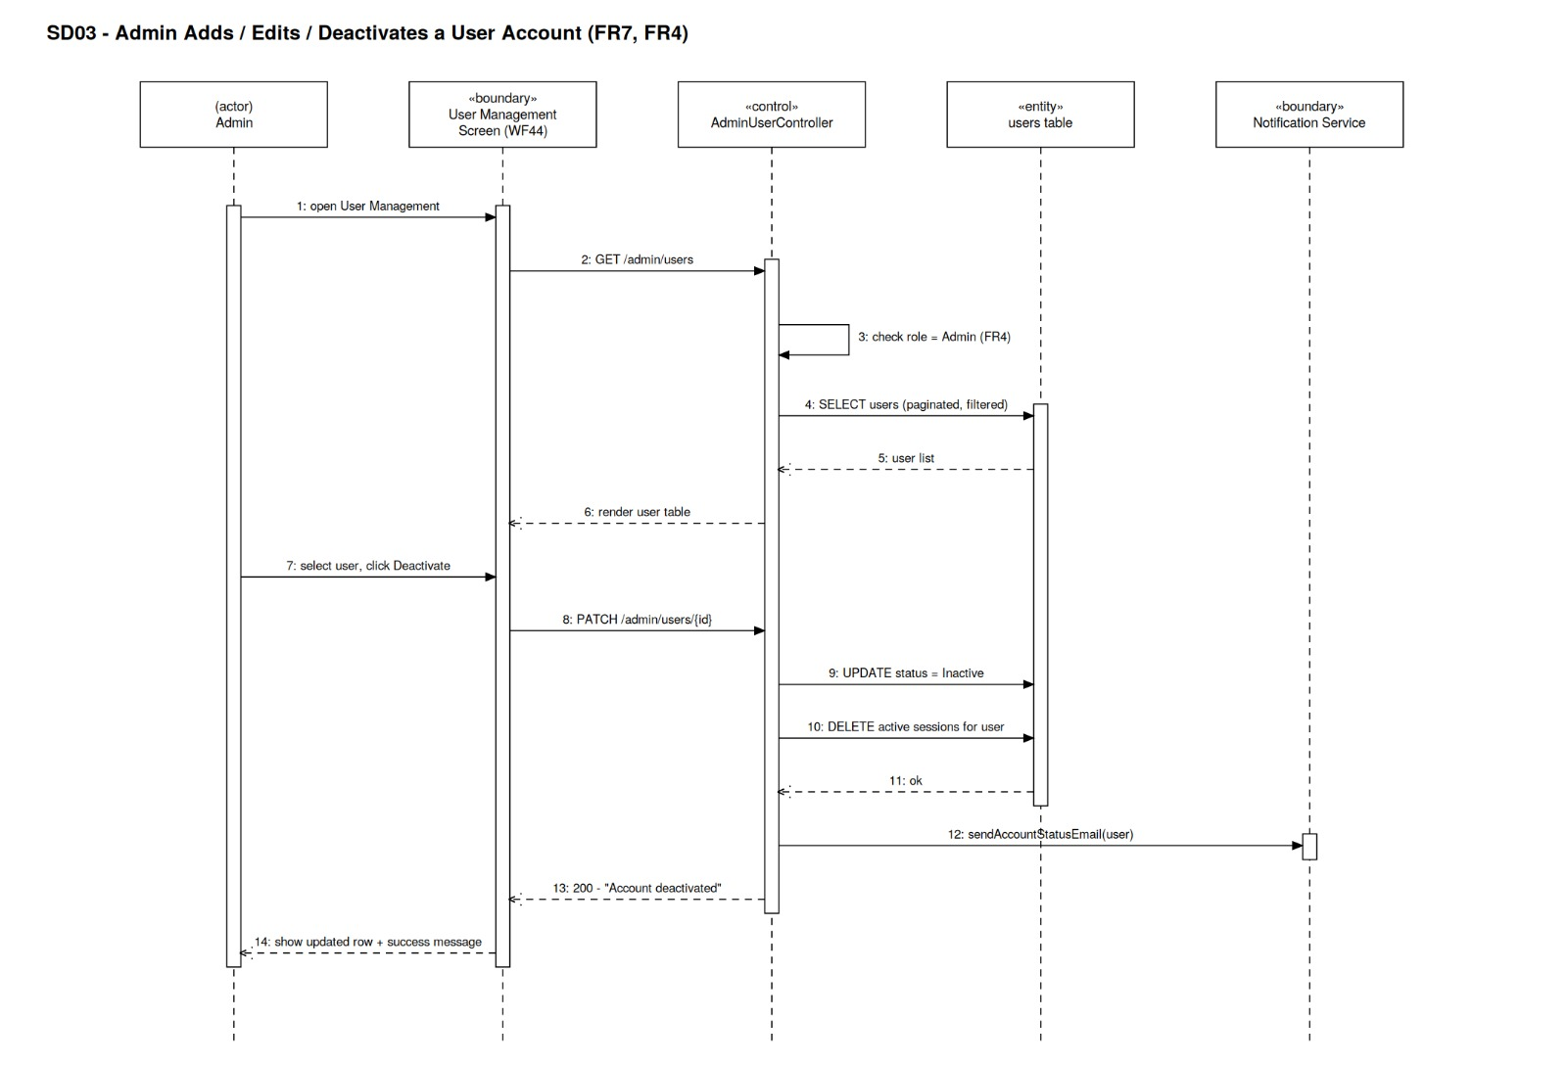
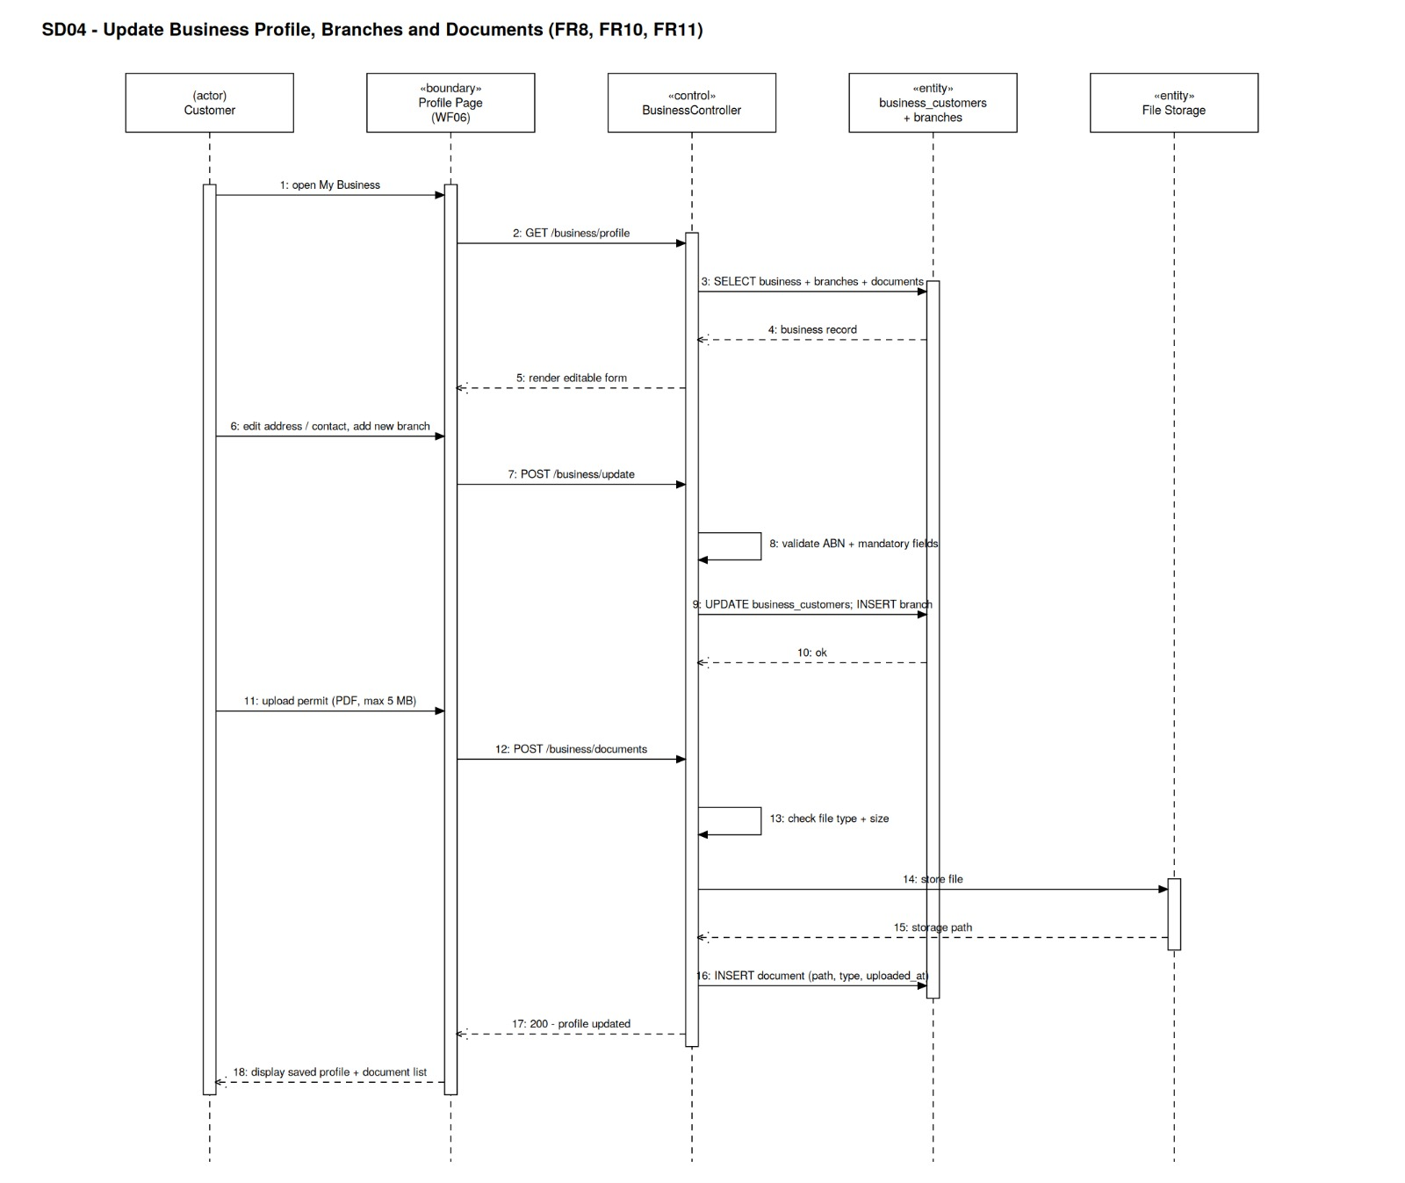
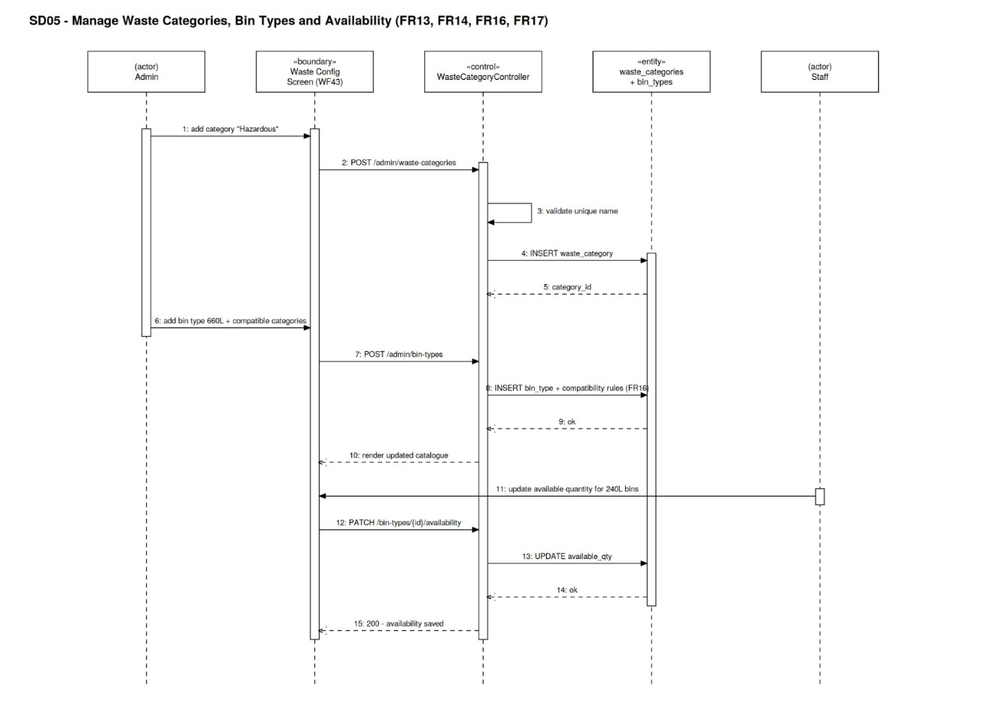
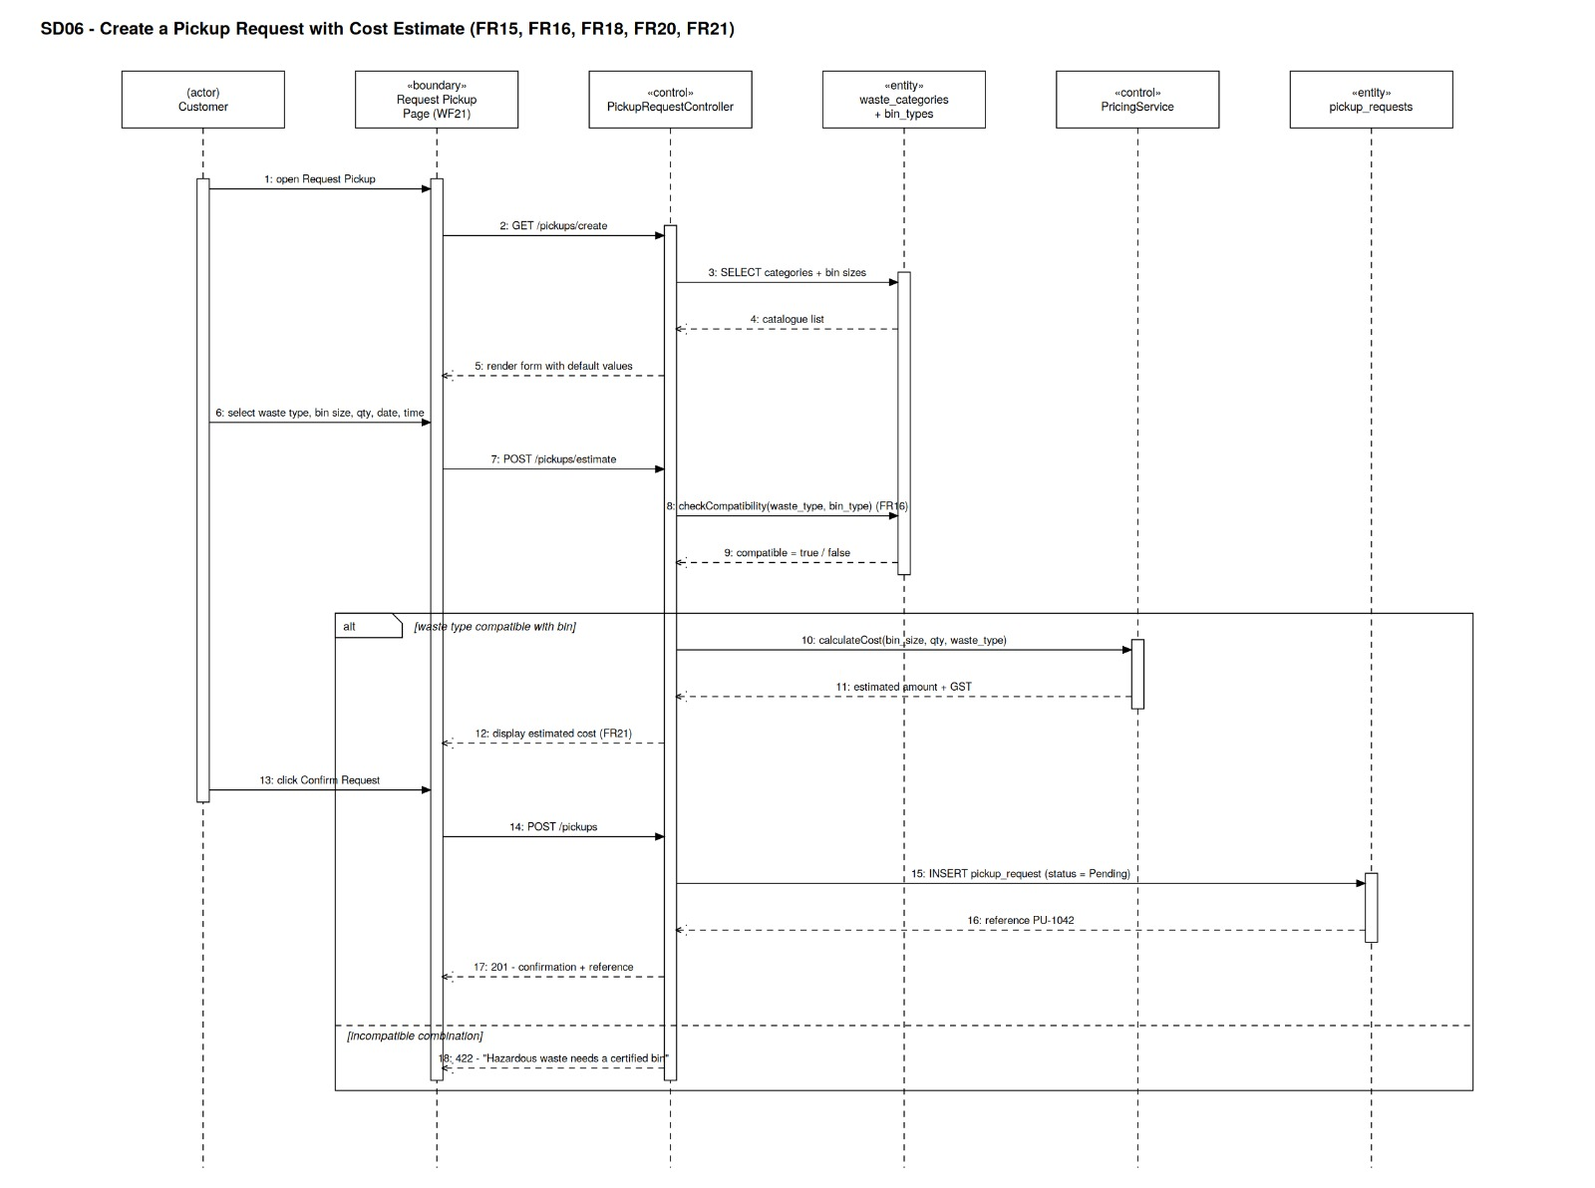
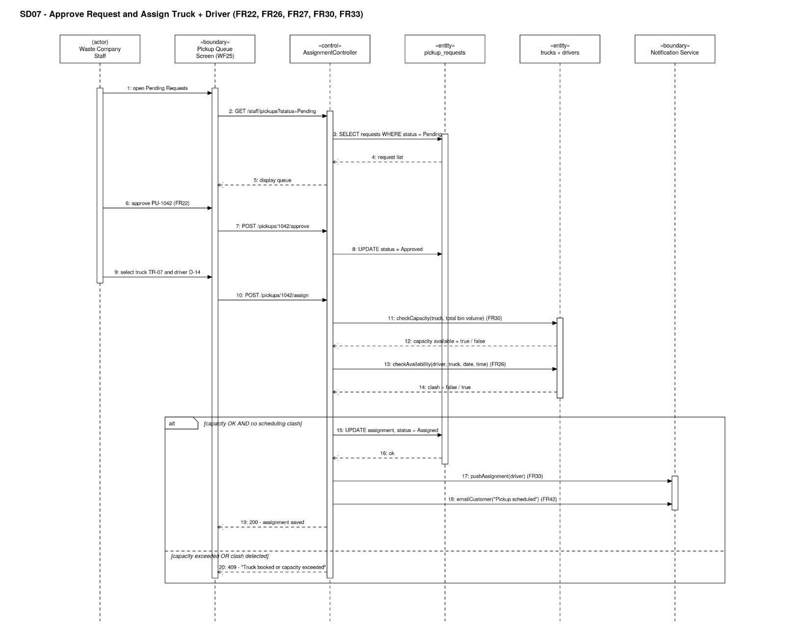
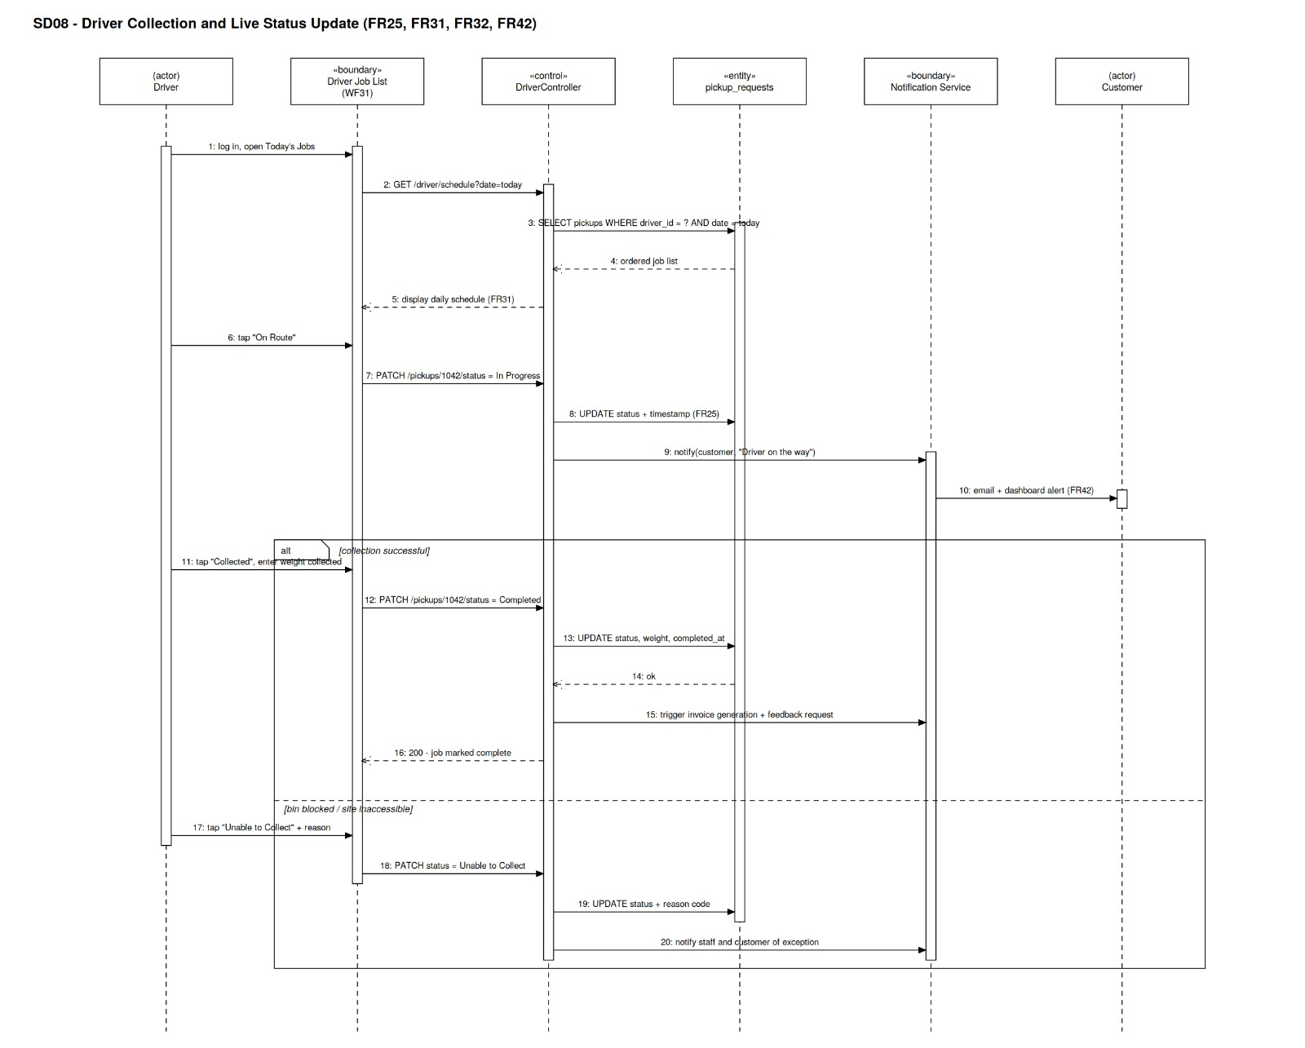
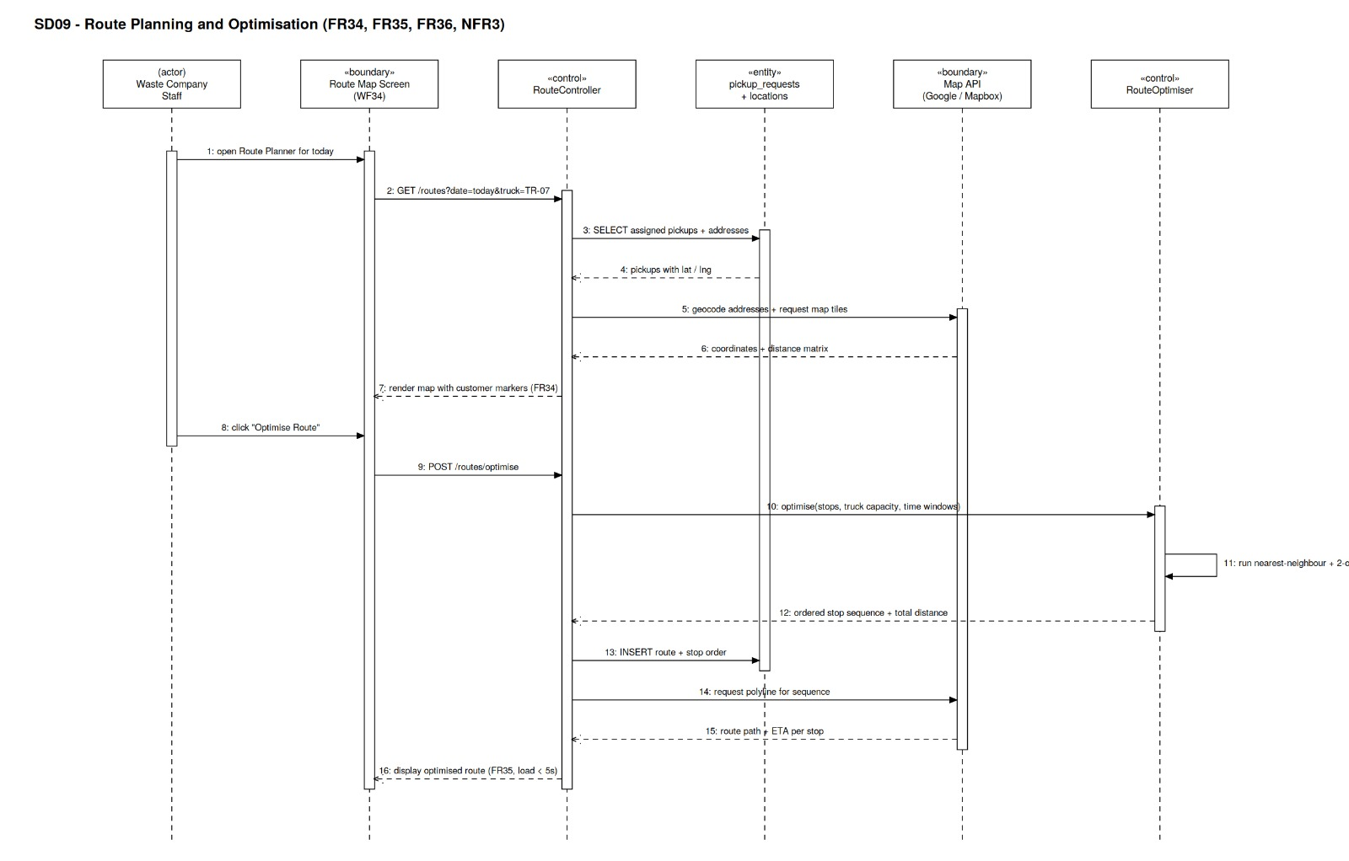

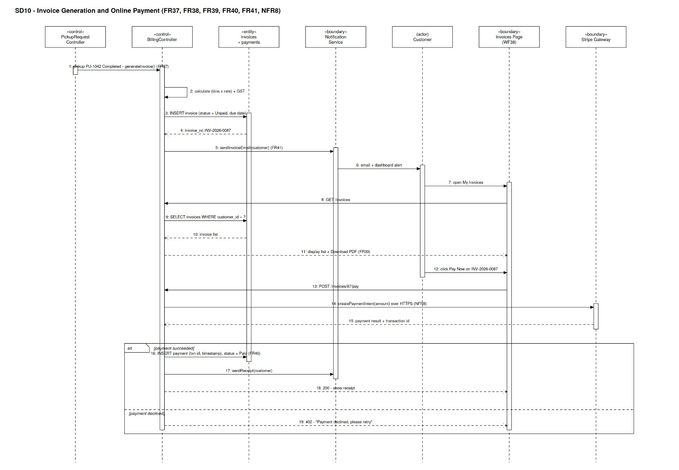
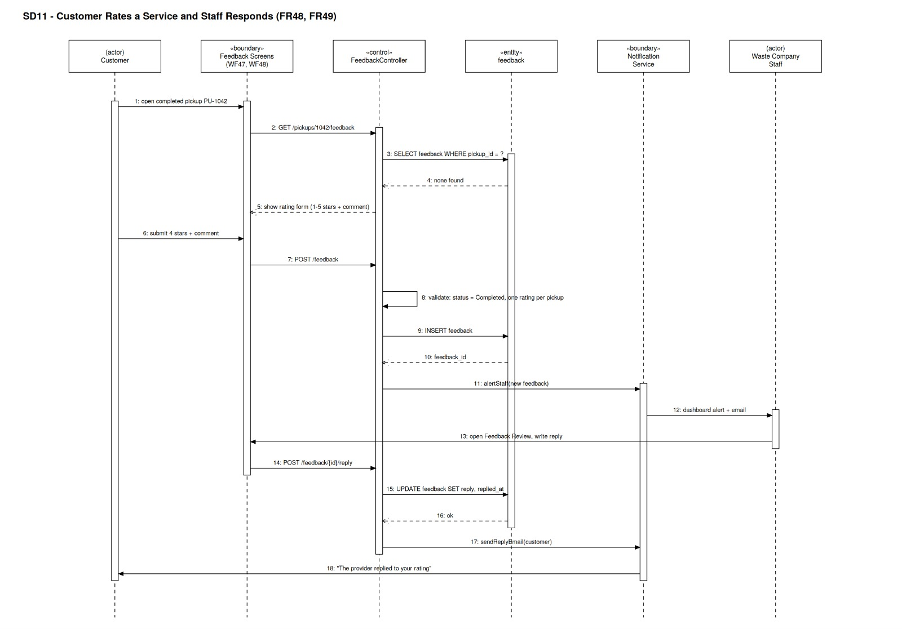

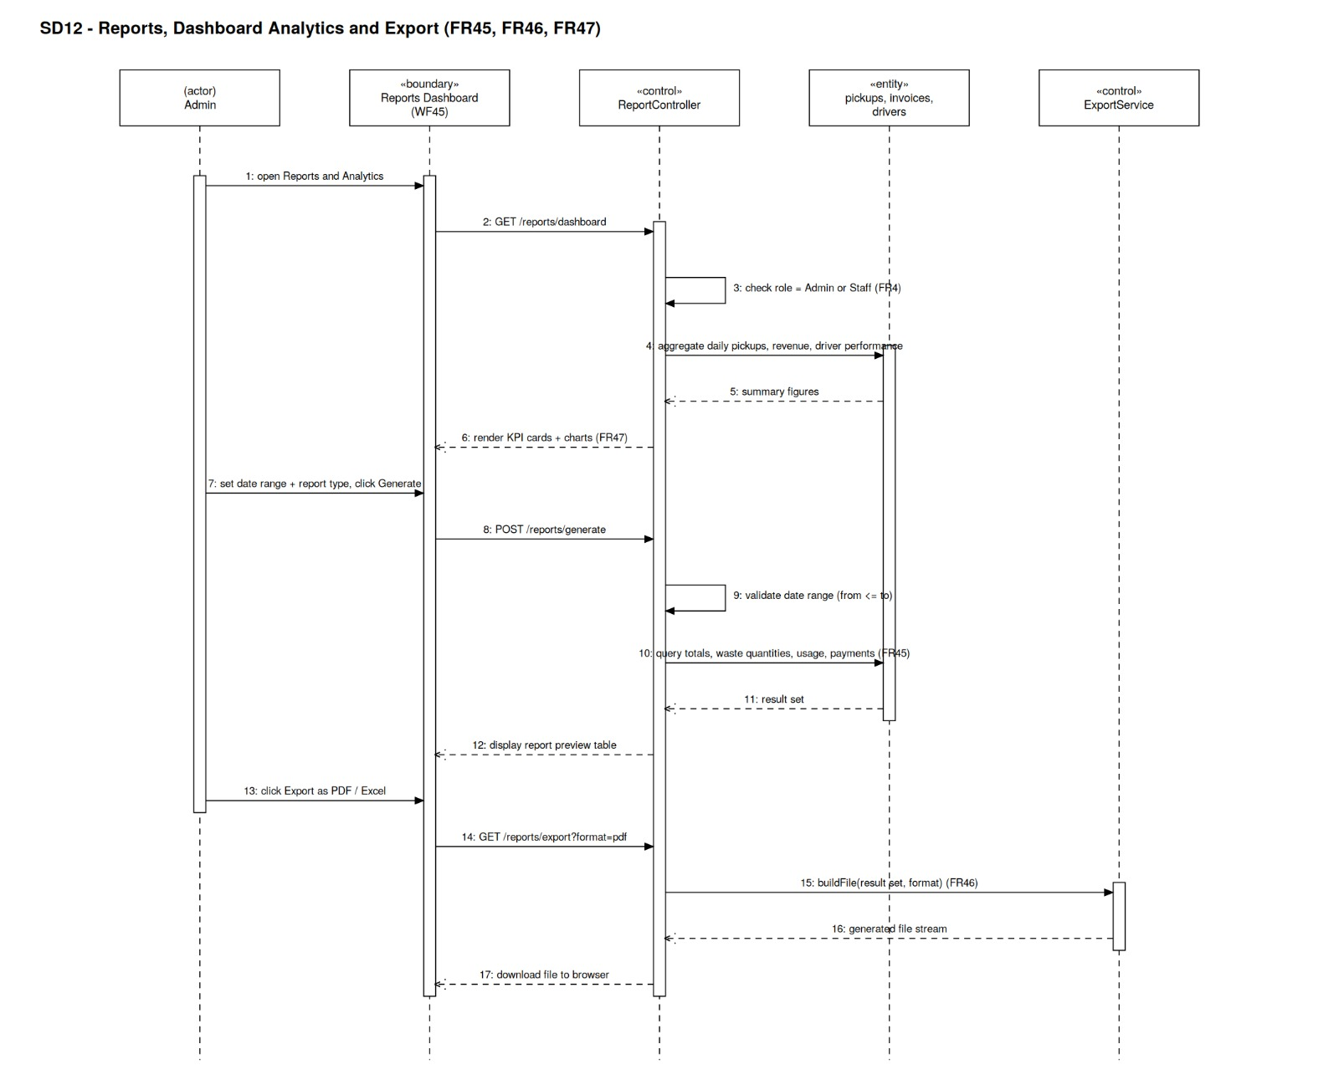
This section presents the sequence diagrams for the BINCOL Online Commercial Waste Collection System. Sequence diagrams are used to model the interactions between actors and system components over time, showing the sequence of messages exchanged to complete a specific process or functionality.
Each diagram illustrates a particular user interaction scenario, starting from the actor at the top of the diagram and progressing downward through the system components. The diagrams cover the key functional areas of the system, including user registration, login, booking creation, payment processing, driver assignment, route management, notification delivery, and feedback submission.
The sequence diagrams complement the use case diagrams and data flow diagrams by providing a dynamic view of how the system behaves during specific interactions. They also demonstrate the flow of data between the presentation tier, application tier, and data tier as described in Section 4.1 (System Architecture).
A total of 12 sequence diagrams are included, each corresponding to a key functional requirement or user journey within the system.

